Tutorial 2:

Presidio-analyzer running:

Example:

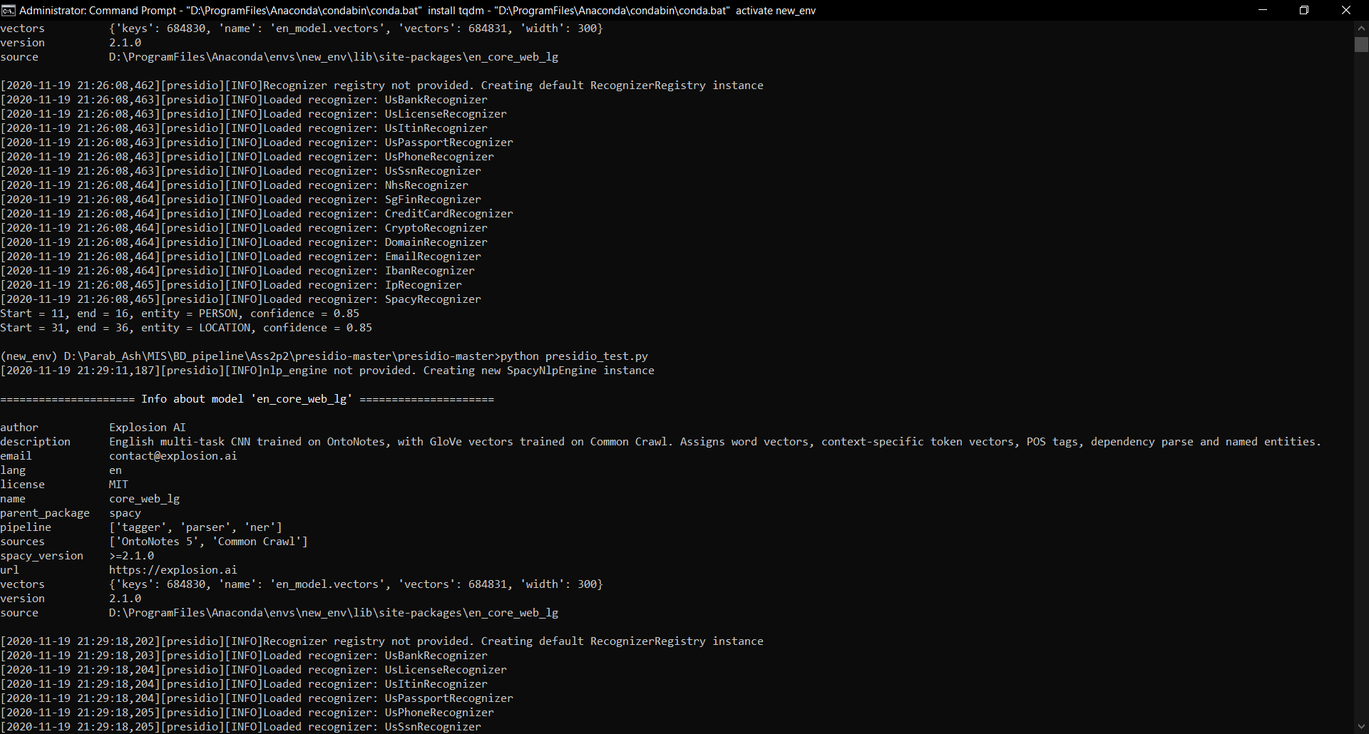

Trying with different text:

